Pastor’s Bible Class

The Fourth Sunday in Advent – Series C

# 357 “O Come, O Come Emmanuel”

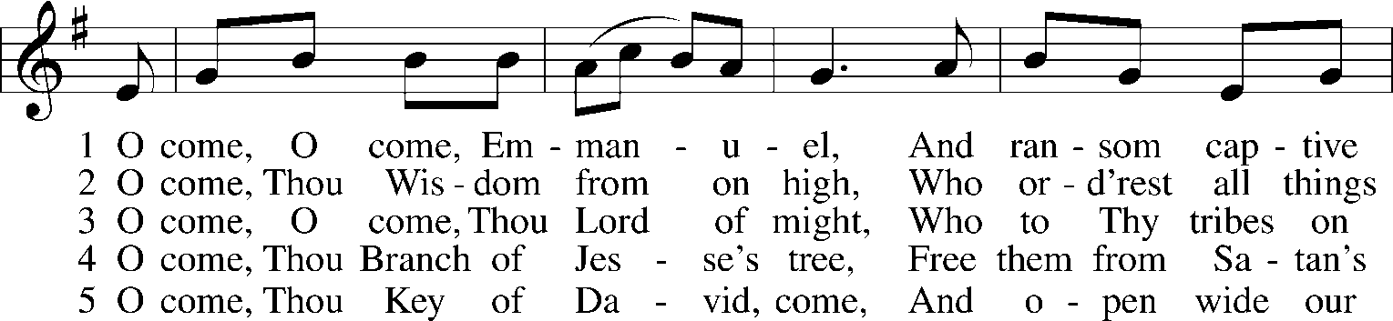
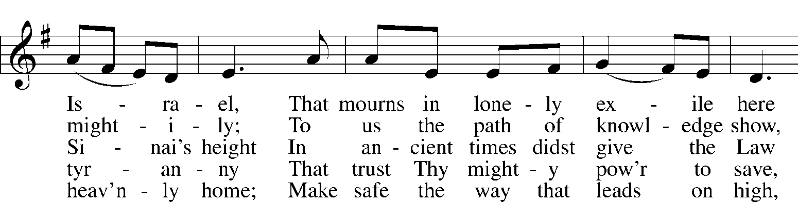
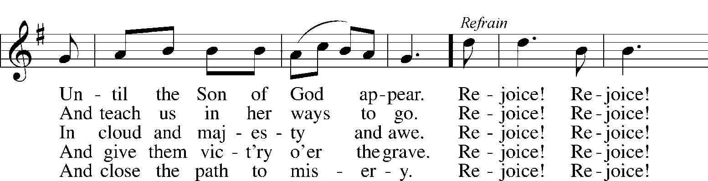

Read Micah 5:2-5
Bethlehem (v. 2) had a notable history. Benjamin, the last son of Jacob was born near the town. His mother Rachel died in childbirth and was buried here. Bethlehem had remained a small town, too small to be named among the more than 100 cities belonging to the clans of Judah. Ephrathah (v. 2) was the region in which Bethlehem was located. It would be like saying Ft. Wayne, Indiana.
- What does the “smallness” of Bethlehem tell you about how God works?

- What does verse 2 predict?

- What does verse 2 say about what He will do and His origin?

- The spiritual leaders of physical Israel would lead the people away from God. God’s people would be led off into exile. Only a small group would return to Israel. At the time of Jesus’s birth those who had returned were under Roman rule (v. 3). What does this say about God and His keeping His promises in spite of His chosen people’s behavior?

- From whom else do we hear “shepherd” language? (John 10:1-18) Look at verse 4-5. What are the benefits of Christ being our Shepherd?

Read Luke 1:39-56
- What is the irony in Mary the mother of Jesus going to see Elizabeth the mother of John the Baptist?

- Who is at work for Elizabeth knowing that Mary was carrying Jesus? How did the unborn John react?

- Mary’s blessedness is a state of faith that grasps the future promises of God that are already beginning to come to fulfillment for her and in her. How is that illustrated in Luke 1:29-38, especially verse 38?

- Mary went to Elizabeth to share her good news. What can we do with THE GOOD NEWS that comes at Christmas?

- Verses 46-55 form what is called the Magnificat. It means “glorifies.” We can find it as a canticle (song or chant) on pages 933-935 in the Lutheran Service Book. It is hymn of praise of the great works and deeds of God. It is meant to strengthen our faith and be a comfort to all.

- When Mary says “God my Savior” she uses an often used title for God, especially in Psalms. It underscores not only His rescue from physical calamity but also His saving power in spiritual matters (v. 47). How is that comforting to you in your personal life?

- Mary humbly acknowledges herself as God’s servant (v 38). In what ways can we be God’s servants?

- When she uses the word “fear” (v. 50) it refers to the holy awe and respect which one has for the “Mighty One” (v. 49) of whom Mary has just spoken. How does that definition fit with what Luther says we are to do in each of the commandments?

- In Mary’s praise she recalls the promises made to Abraham and David (vv. 48, 55). Think of ways you can learn about many of God’s promises and thank Him for keeping each one.

Devotional Thought and Prayer (The Lutheran Study Bible)
The Lord delivers His people amid suffering and disappointment. Today, no matter what troubles assail you, trust in the Lord as your deliverer, and commend all cares to Him in prayer. Rejoice in His surpassing mercy through the Holy Child, who delivers the generations from sin and sorrow. • Pray or sing the Magnificat (vv 46–55; LSB, pp 248–49). (TLSB, 1707)

