Pastor’s Bible Class

The Nineteenth Sunday after Pentecost

#700 “Love Divine, All Loves Excelling”
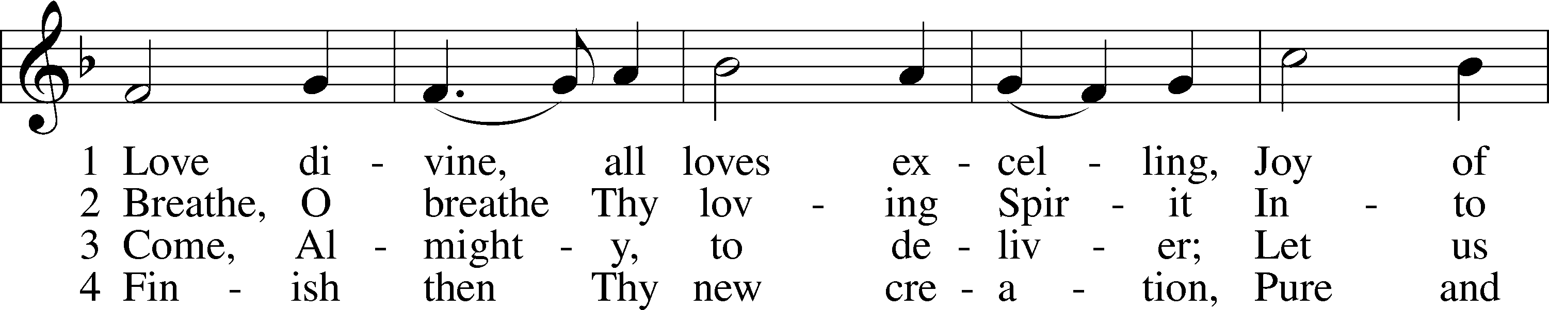
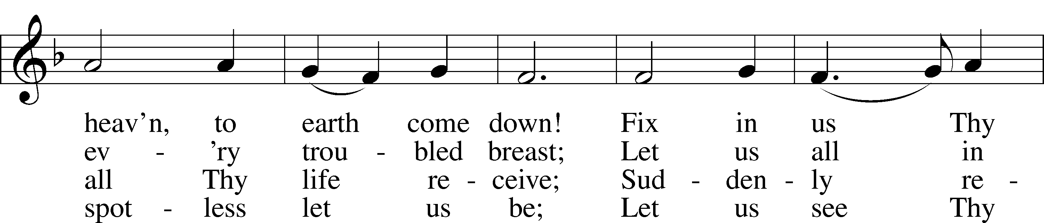
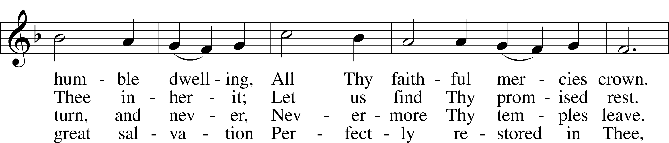
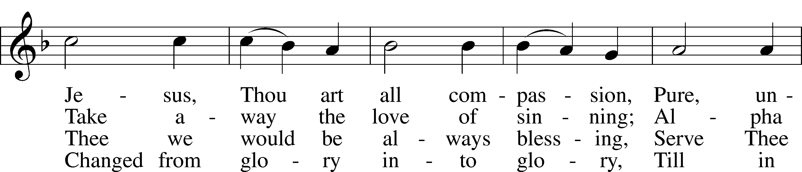
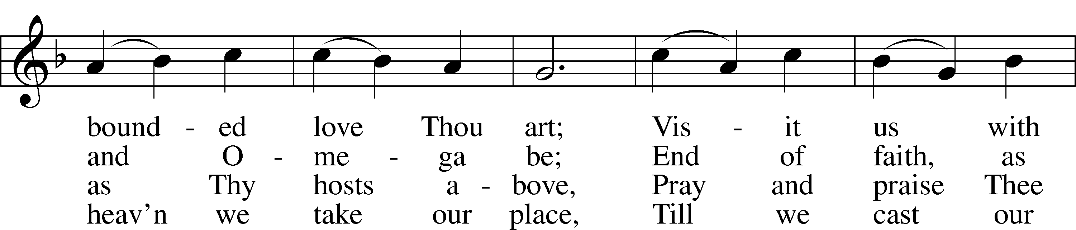
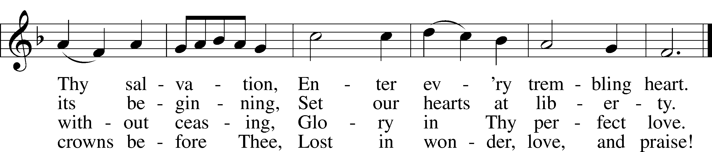

Read Numbers 11:4-6, 10-17, 24-29
1. Speaking about verse 4, Matthew Henry wrote that “the rabble” were those who, “…came with them out of Egypt, expecting only the land of promise, but not a state of probation in the way to it. They were hangers on, who took hold of the skirts of the Jews, and would go with them only because they knew not how to live at home, and were disposed to seek their fortunes (as we say) abroad. These were the scabbed sheep that infected the flock, the leaven that leavened the whole lump.” What is the effect of “the mixed multitude” (KJV) on the Israelites?

2. Why is this complaint of the Israelites so shocking? Look back to the beginning of this chapter.

3. In verse 10, we are told “the anger of the Lord blazed hotly” at the complaints of the people. How does Moses respond in verses 10-15 and what is God’s response to Moses’ complaint ini verses 16 and 17?

4. What is the cause of Joshua’s concern in verse 28?

5. How does Moses respond and what are the implications of this response for the Church today?

Read Mark 9:38-50
6. Read the exchange between Jesus and the disciples in the section leading up to today’s text (Mark 9:33-37). In light of this previous teaching, what does John’s question show?

7. How can we apply Jesus’ response to John in verses 39-40 to our experience in the Church?

8. In verse 41, Jesus references the giving of “a cup of water” as an act worthy of reward. What does this mean?

9. Who is the target of Jesus’ rebuke beginning in verse 42? Hint: See Mark 10:13.

10. How does Jesus address the seriousness of sin in verses 42-48?

11. Read Leviticus 2:13 and Matthew 5:13. What do the following verses tells us about salt and how can these help us to understand Jesus words in Mark 9:49-50?

Devotional Thought (The Lutheran Study Bible)
“Jesus opens the disciples’ eyes to see those who do God’s work in dramatic or simple ways. The work of God goes far beyond us. He shows His power and kindness through great life-changing miracles and simple cups of water” (TLSB, 1677).

Prayer
Lord, thank You for Your work through the lives of others. Lead me to welcome those miracle and mercies that You show through every one of your people. Amen.

4. How do the following words relate to God’s action in this text?

One of the most amazing things about God was the way He redefined reality with words. God looked into chaos and spoke the hopeful words of creation. He looked into the chaos of our sin and declared us righteous in Christ. By speaking those words, coupled with our belief in them, He reconstituted our reality. If He had declared us lost He would have spoken truth, but He spoke a greater truth by recreating us with His words. In other words, others might tell me I am a failure, an idiot, a clown, evil, incompetent, vicious, dangerous, pathetic etc., and these words are not just descriptive: they have a certain power to make me these things, in the eyes of others and even in my own eyes, as self-doubt creeps in and the Devil whispers in my ear. But God speaks louder, and his word is more powerful. You may call me a liar, and you speak truth, for I have lied; but if God declares me righteous, then my lies and your insults are not the final word, nor the most powerful word. I have peace in my soul because God’s word is real reality. That’s why I need to read the Bible each day, to hear the word preached each week, to come to God in prayer, and to hear words of grace from other brothers and sisters as I seek to speak the same to them. Only as God speaks his word to me, and as I hear that word in faith, is my reality transformed and do the insults of others, of my own sinful nature, and of the evil one himself, cease to constitute my reality. The words of my enemies, external and internal, might be powerful for a moment, like a firework exploding against the night sky; but the Word of the Lord is stronger, brighter, and lasts forever (Martin Luther).

Mark 9:38-50

HE WHO IS NOT AGAINST US IS FOR US,
AND TEMPTATIONS TO SIN
- Verses 38-41 are paralleled at Luke 9:49-50 in shorter form;
- Verses 42-47 are paralleled at Matthew 18:6-9 and Luke 17:1-2;
- Verses 48-50 are peculiar to Mark.
Textual matters:
- Verses 44 and 46 are not found in the best manuscripts. Nor in modern translations.
- Verse 38: the words "and he followeth not us (KJV)" are not found in the best manuscripts and are therefore omitted by RSV, NEB, BECK, NIV and NASB.
- Verse 49: Nestle's Greek text reading is the preferred reading followed by the five translations mentioned above. On this verse the UBS Textual Commentary states: "At a very early period a scribe, having found in Leviticus 2:13 a clue to the meaning of Jesus' enigmatic statement, wrote the OT passage in the margin of his copy of Mark. In subsequent copyings the marginal gloss was either substituted for the words of the text, or was added to the text."
Verses 38-41 form a unit. 42 is transitional. Verses 43-50 form a second unit.

Mark 9:38 "Teacher," said John, "we saw a man driving out demons in your name and we told him to stop, because he was not one of us."
There is no conjunction or particle. John interrupts Jesus. What he says indicates that he was not sure whether he had done the right thing. "We were trying to prevent him." Note that he says "us" not "you." He judges simply by membership in the circle of the disciples, who had been commanded to drive out devils.

Mark 9:39 "Do not stop him," Jesus said. "No one who does a miracle in my name can in the next moment say anything bad about me,"
"Stop preventing him" likely indicates that the man is still doing so. "In the next moment" is "in the same breath." "Say anything bad" or "speak evil" means "he believes in Me."

Mark 9:40 for whoever is not against us is for us.
This verse states a Christian axiom. Note Matthew 12:30, an opposite thought, found in a context of those who reject Jesus. The use of "us" in verse 40 includes Jesus. In verse 38 it obviously excludes Jesus. Both this verse and Matthew 12:30 tell us that no one can be neutral to Jesus.

Mark 9:41 I tell you the truth, anyone who gives you a cup of water in my name because you belong to Christ will certainly not lose his reward.
This explanation cites a specific case which however is general. Intended sense: a deed, no matter how insignificant, done "on the ground that you are Christ's" will always be rewarded. That is the attitude they should have toward such as are mentioned in verses 38-39, not an attitude of exclusion.

Mark 9:42 "And if anyone causes one of these little ones who believe in me to sin, it would be better for him to be thrown into the sea with a large millstone tied around his neck."
The very opposite of verse 37 and a glaring contrast with verse 41. It is a general statement covering all instances of this kind. "Cause to sin" is "to entrap." NEB: "Leads astray." "Believe in Me" surely means faith in Christ. Little children can believe. KJV, RSV and NASB make the apodosis a contrary to fact condition "and had been cast into the sea." Grammars argue about the meaning of "if" or "that" here. It makes little difference. The meaning is clear: "Better to die a violent and cruel death than to cause one of these little believers to sin." Christians must control their flesh so as not to mislead others.

Mark 9:43 If your hand causes you to sin, cut it off. It is better for you to enter life maimed than with two hands to go into hell, where the fire never goes out.
Verses 43-47 (with 44 and 46 omitted) comprise a three-fold warning to the Christian with reference to self:
- These words do not condone self-mutilation and therefore are not to be taken literally. If they were taken literally we would soon have no members left, for our flesh tempts us often. They are sternest law: drown all lust and temptation immediately. Note the three aorist imperatives in 43, 45 and 47.
- The warning not to scandalize others occurs only once, verse 42, but the warning not to scandalize self is given thrice.
- "To enter life," verse 43, occurs again in 45 and 47. "Enter the Kingdom" is the eschatological Kingdom of God in heaven. The word "life" occurs four times in Mark, twice here and at 10:17,30. It reminds one of the very frequent use in John's Gospel.
- "Go into hell," verse 43, he enters hell on his own accord but in 45 and 47 we note that he has no choice. The word used for hell here "geenna," in verses 43, 45 and 47 always means "hell" in the New Testament.

Mark 9:44 (KJV) Where their worm dieth not, and the fire is not quenched.

Mark 9:45 And if your foot causes you to sin, cut it off. It is better for you to enter life crippled than to have two feet and be thrown into hell.

Mark 9:46 (KJV) Where their worm dieth not, and the fire is not quenched.

Mark 9:47 And if your eye causes you to sin, pluck it out. It is better for you to enter the kingdom of God with one eye than to have two eyes and be thrown into hell,

Mark 9:48 where "'their worm does not die, and the fire is not quenched.'"
"Their" is the damned in hell. Hell is pictured as everlasting internal corruption and putrefaction and external torture. Look at 2 Thessalonians 1:9, eternal objects of God's wrath.
Verses 42-48 are a stern warning. Who is not guilty and who does not need warning?

Mark 9:49 Everyone will be salted with fire.
This verse is a Gospel promise. It explains, and denotes the way out for the condemned sinner who is conscious of his guilt. "Everyone" denotes every Christian. "Will be salted" means "will be cleansed, will be purified." "With fire" is dative of means and denotes the Word of God. Look at John 15:2-3. Note that "fire" has a radically different meaning here than in verse 48. For a parallel example compare Luke 3:16-17, where "fire" has distinctly different meanings. By the way, the difference between Lutheran and Reformed theology is evident in the explanation of verse 49. Lenski interprets "fire" as the Word and the Spirit. But Hendriksen: "A fiery trial will come upon everybody, for the purpose of purification." Obviously he says this because he does not believe that the Word is the means of grace.

Mark 9:50 "Salt is good, but if it loses its saltiness, how can you make it salty again? Have salt in yourselves, and be at peace with each other."
The first three words are axiomatic. Everyone will agree with this statement. Note that predicate adjective is placed for emphasis: "The salt is truly good." And likely the article indicates a particular type of salt, the Word and the Spirit.
Next follows a rhetorical question, a good teaching device. Without salt there can be no seasoning. Without the Word and Spirit there can be no forgiveness, no battle again sin, no everlasting life. By the way, this sentence does away with the idea: "Once in grace, always in grace."
The final sentence is a compound sentence, with compound imperatives, contrasting reflexive and reciprocal action. A connecting word "and so" in the Greek, not translated here, likely means "and thus." Only when we have the Word and Spirit in ourselves can we have peace among ourselves. We have come full circle from verses 34 and 35. The only cure for pride, prejudice, offense and living in sin is the salt of the Word and the Spirit. This will keep us at peace with each other. Note again that verses 48-50 are found only here in Mark.
Stoeckhardt: He who tames his members with the help of the Holy Spirit, holds himself within bounds, does not give sin free reign, he keeps his faith and a good conscience, keeps his body and should to everlasting life. The Lord demands a painful offering from His disciples, the offering of their own members . . . Christians, who are sanctified and make progress in sanctification through the Word and Spirit of the Lord, must always have this salt and with God's Word and Spirit must part ways with the rotten deeds of the world, rather than to permit themselves to be lured into sin by the world, but must practice mutual peace and must not consider themselves superior to others.

Pastor’s Bible Class
September 23, 2009

The Readings for the Seventeenth Sunday after Pentecost

Read Numbers 11:4-6, 10-16, 24-29

1. Speaking about verse 4, Matthew Henry wrote that “the rabble” were those who, “…came with them out of Egypt, expecting only the land of promise, but not a state of probation in the way to it. They were hangers on, who took hold of the skirts of the Jews, and would go with them only because they knew not how to live at home, and were disposed to seek their fortunes (as we say) abroad. These were the scabbed sheep that infected the flock, the leaven that leavened the whole lump.” What is the effect of “the mixed multitude” (KJV) on the Israelites?

2. Why is this complaint of the Israelites so shocking (Look back to the beginning of this chapter.)?

3. The Lord gets “exceedingly angry” at the complaints of the people. How does Moses respond in verses 10-15?

4. What is God’s response to Moses complaint?

5. How do the following excerpts relate to God’s action?

One of the most amazing things about God was the way He redefined reality with words. God looked into chaos and spoke the hopeful words of creation. He looked into the chaos of our sin and declared us righteous in Christ. By speaking those words, coupled with our belief in them, He reconstituted our reality. If He had declared us lost He would have spoken truth, but He spoke a greater truth by recreating us with His words.
In other words, others might tell me I am a failure, an idiot, a clown, evil, incompetent, vicious, dangerous, pathetic etc., and these words are not just descriptive: they have a certain power to make me these things, in the eyes of others and even in my own eyes, as self-doubt creeps in and the Devil whispers in my ear.
But God’s speaks louder, and his word is more powerful. You may call me a liar, and you speak truth, for I have lied; but if God declares me righteous, then my lies and your insult are not the final word, nor the most powerful word. I have peace in my soul because God’s word is real reality. That’s why I need to read the Bible each day, to hear the word preached each week, to come to God in prayer, and to hear words of grace from other brothers and sisters as I seek to speak the same to them. Only as God speaks his word to me, and as I hear that word in faith, is my reality transformed and do the insults of others, of my own sinful nature, and of the evil one himself, cease to constitute my reality. The words of my enemies, external and internal, might be powerful for a moment, like a firework exploding against the night sky; but the Word of the Lord is stronger, brighter, and lasts forever.
-Martin Luther

Dietrich Bonhoeffer writes, “God has put his Word into the mouth of men in order that it may be communicated to other men. When one person is struck by the Word, he speaks it to others. God willed that we should seek and find His living Word in the witness of a brother, in the mouth of man. Therefore, the Christian needs another Christian who speaks God’s Word to him. He needs him again and again when he becomes uncertain and discouraged, for by himself he cannot help himself without belying the truth. He needs his brother as a bearer and proclaimer of the divine word of salvation. He needs his brother solely because of Jesus Christ. The Christ in his own heart is weaker than the Christ in the word of his brother; his own heart is uncertain, his brother’s is sure. And that also clarifies the goal of all Christian community: they meet one another as bringers of the message of salvation” (Life Together, 22-23).

Read Mark 9:38-50

6. How can we apply Jesus’ response to John in verses 39-40 to our experience in the Church?

7. In verse 41 Jesus references the giving of “a cup of water” in His name as an act worthy of reward. What does this mean? See the repetition of “in my name” as a key.

8. How does Jesus address the seriousness of sin in verses 42-48?

a. Verse 42:

b. Verse 43:

c. Verse 45:

d. Verse 47:

9. What do the following verses tells us about salt and how can these help us to understand Jesus words in Mark 9:49-50?

a. Leviticus 2:13

b. Matthew 5:13

Mark 9:38-50

HE WHO IS NOT AGAINST US IS FOR US,
AND TEMPTATIONS TO SIN
- Verses 38-41 are paralleled at Luke 9:49-50 in shorter form;
- Verses 42-47 are paralleled at Matthew 18:6-9 and Luke 17:1-2;
- Verses 48-50 are peculiar to Mark.
Textual matters:
- Verses 44 and 46 are not found in the best manuscripts. Nor in modern translations.
- Verse 38: the words "and he followeth not us (KJV)" are not found in the best manuscripts and are therefore omitted by RSV, NEB, BECK, NIV and NASB.
- Verse 49: Nestle's Greek text reading is the preferred reading followed by the five translations mentioned above. On this verse the UBS Textual Commentary states: "At a very early period a scribe, having found in Leviticus 2:13 a clue to the meaning of Jesus' enigmatic statement, wrote the OT passage in the margin of his copy of Mark. In subsequent copyings the marginal gloss was either substituted for the words of the text, or was added to the text."
Verses 38-41 form a unit. 42 is transitional. Verses 43-50 form a second unit.

Mark 9:38 "Teacher," said John, "we saw a man driving out demons in your name and we told him to stop, because he was not one of us."
There is no conjunction or particle. John interrupts Jesus. What he says indicates that he was not sure whether he had done the right thing. "We were trying to prevent him." Note that he says "us" not "you." He judges simply by membership in the circle of the disciples, who had been commanded to drive out devils.

Mark 9:39 "Do not stop him," Jesus said. "No one who does a miracle in my name can in the next moment say anything bad about me,"
"Stop preventing him" likely indicates that the man is still doing so. "In the next moment" is "in the same breath." "Say anything bad" or "speak evil" means "he believes in Me."

Mark 9:40 for whoever is not against us is for us.
This verse states a Christian axiom. Note Matthew 12:30, an opposite thought, found in a context of those who reject Jesus. The use of "us" in verse 40 includes Jesus. In verse 38 it obviously excludes Jesus. Both this verse and Matthew 12:30 tell us that no one can be neutral to Jesus.

Mark 9:41 I tell you the truth, anyone who gives you a cup of water in my name because you belong to Christ will certainly not lose his reward.
This explanation cites a specific case which however is general. Intended sense: a deed, no matter how insignificant, done "on the ground that you are Christ's" will always be rewarded. That is the attitude they should have toward such as are mentioned in verses 38-39, not an attitude of exclusion.

Mark 9:42 "And if anyone causes one of these little ones who believe in me to sin, it would be better for him to be thrown into the sea with a large millstone tied around his neck."
The very opposite of verse 37 and a glaring contrast with verse 41. It is a general statement covering all instances of this kind. "Cause to sin" is "to entrap." NEB: "Leads astray." "Believe in Me" surely means faith in Christ. Little children can believe. KJV, RSV and NASB make the apodosis a contrary to fact condition "and had been cast into the sea." Grammars argue about the meaning of "if" or "that" here. It makes little difference. The meaning is clear: "Better to die a violent and cruel death than to cause one of these little believers to sin." Christians must control their flesh so as not to mislead others.

Mark 9:43 If your hand causes you to sin, cut it off. It is better for you to enter life maimed than with two hands to go into hell, where the fire never goes out.
Verses 43-47 (with 44 and 46 omitted) comprise a three-fold warning to the Christian with reference to self:
- These words do not condone self-mutilation and therefore are not to be taken literally. If they were taken literally we would soon have no members left, for our flesh tempts us often. They are sternest law: drown all lust and temptation immediately. Note the three aorist imperatives in 43, 45 and 47.
- The warning not to scandalize others occurs only once, verse 42, but the warning not to scandalize self is given thrice.
- "To enter life," verse 43, occurs again in 45 and 47. "Enter the Kingdom" is the eschatological Kingdom of God in heaven. The word "life" occurs four times in Mark, twice here and at 10:17,30. It reminds one of the very frequent use in John's Gospel.
- "Go into hell," verse 43, he enters hell on his own accord but in 45 and 47 we note that he has no choice. The word used for hell here "geenna," in verses 43, 45 and 47 always means "hell" in the New Testament.

Mark 9:44 (KJV) Where their worm dieth not, and the fire is not quenched.

Mark 9:45 And if your foot causes you to sin, cut it off. It is better for you to enter life crippled than to have two feet and be thrown into hell.

Mark 9:46 (KJV) Where their worm dieth not, and the fire is not quenched.

Mark 9:47 And if your eye causes you to sin, pluck it out. It is better for you to enter the kingdom of God with one eye than to have two eyes and be thrown into hell,

Mark 9:48 where "'their worm does not die, and the fire is not quenched.'"
"Their" is the damned in hell. Hell is pictured as everlasting internal corruption and putrefaction and external torture. Look at 2 Thessalonians 1:9, eternal objects of God's wrath.
Verses 42-48 are a stern warning. Who is not guilty and who does not need warning?

Mark 9:49 Everyone will be salted with fire.
This verse is a Gospel promise. It explains, and denotes the way out for the condemned sinner who is conscious of his guilt. "Everyone" denotes every Christian. "Will be salted" means "will be cleansed, will be purified." "With fire" is dative of means and denotes the Word of God. Look at John 15:2-3. Note that "fire" has a radically different meaning here than in verse 48. For a parallel example compare Luke 3:16-17, where "fire" has distinctly different meanings. By the way, the difference between Lutheran and Reformed theology is evident in the explanation of verse 49. Lenski interprets "fire" as the Word and the Spirit. But Hendriksen: "A fiery trial will come upon everybody, for the purpose of purification." Obviously he says this because he does not believe that the Word is the means of grace.

Mark 9:50 "Salt is good, but if it loses its saltiness, how can you make it salty again? Have salt in yourselves, and be at peace with each other."
The first three words are axiomatic. Everyone will agree with this statement. Note that predicate adjective is placed for emphasis: "The salt is truly good." And likely the article indicates a particular type of salt, the Word and the Spirit.
Next follows a rhetorical question, a good teaching device. Without salt there can be no seasoning. Without the Word and Spirit there can be no forgiveness, no battle again sin, no everlasting life. By the way, this sentence does away with the idea: "Once in grace, always in grace."
The final sentence is a compound sentence, with compound imperatives, contrasting reflexive and reciprocal action. A connecting word "and so" in the Greek, not translated here, likely means "and thus." Only when we have the Word and Spirit in ourselves can we have peace among ourselves. We have come full circle from verses 34 and 35. The only cure for pride, prejudice, offense and living in sin is the salt of the Word and the Spirit. This will keep us at peace with each other. Note again that verses 48-50 are found only here in Mark.
Stoeckhardt: He who tames his members with the help of the Holy Spirit, holds himself within bounds, does not give sin free reign, he keeps his faith and a good conscience, keeps his body and should to everlasting life. The Lord demands a painful offering from His disciples, the offering of their own members . . . Christians, who are sanctified and make progress in sanctification through the Word and Spirit of the Lord, must always have this salt and with God's Word and Spirit must part ways with the rotten deeds of the world, rather than to permit themselves to be lured into sin by the world, but must practice mutual peace and must not consider themselves superior to others.

