Pastor’s Bible Class

The Seventh Sunday of Easter

#644 “The Church's One Foundation”
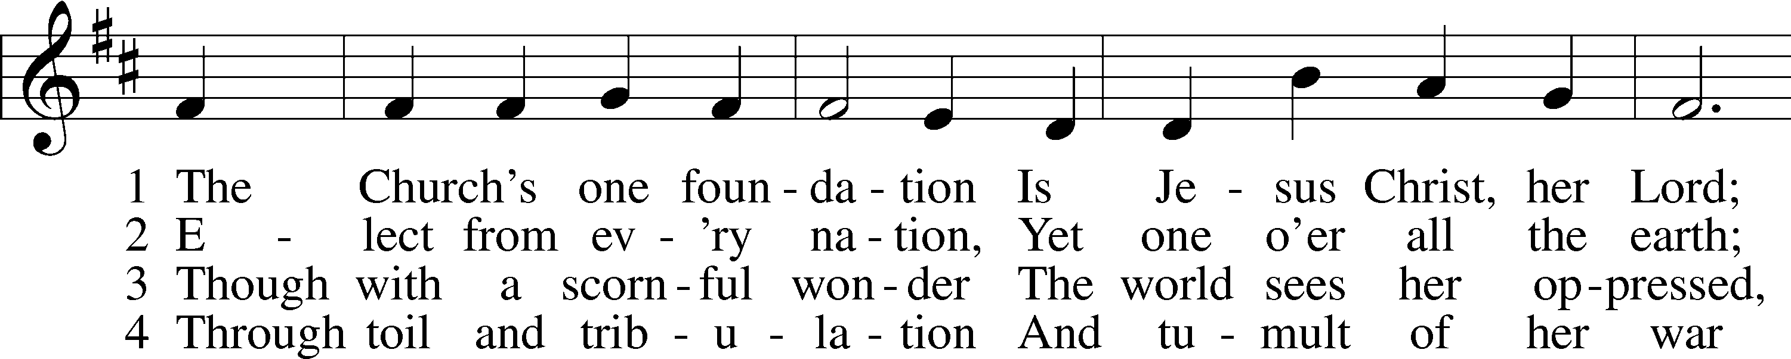
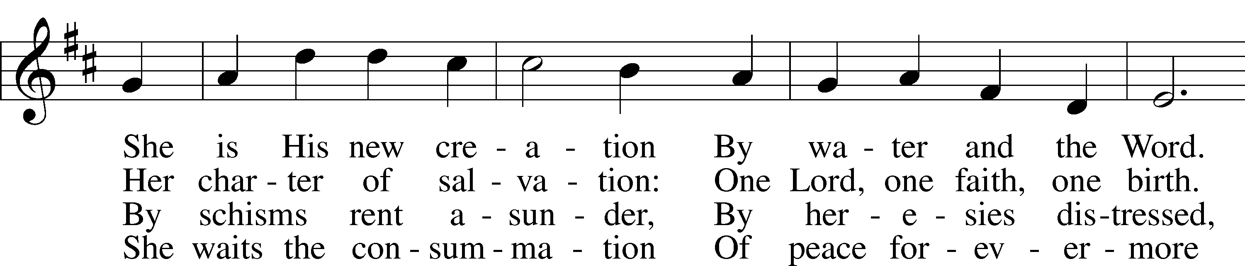
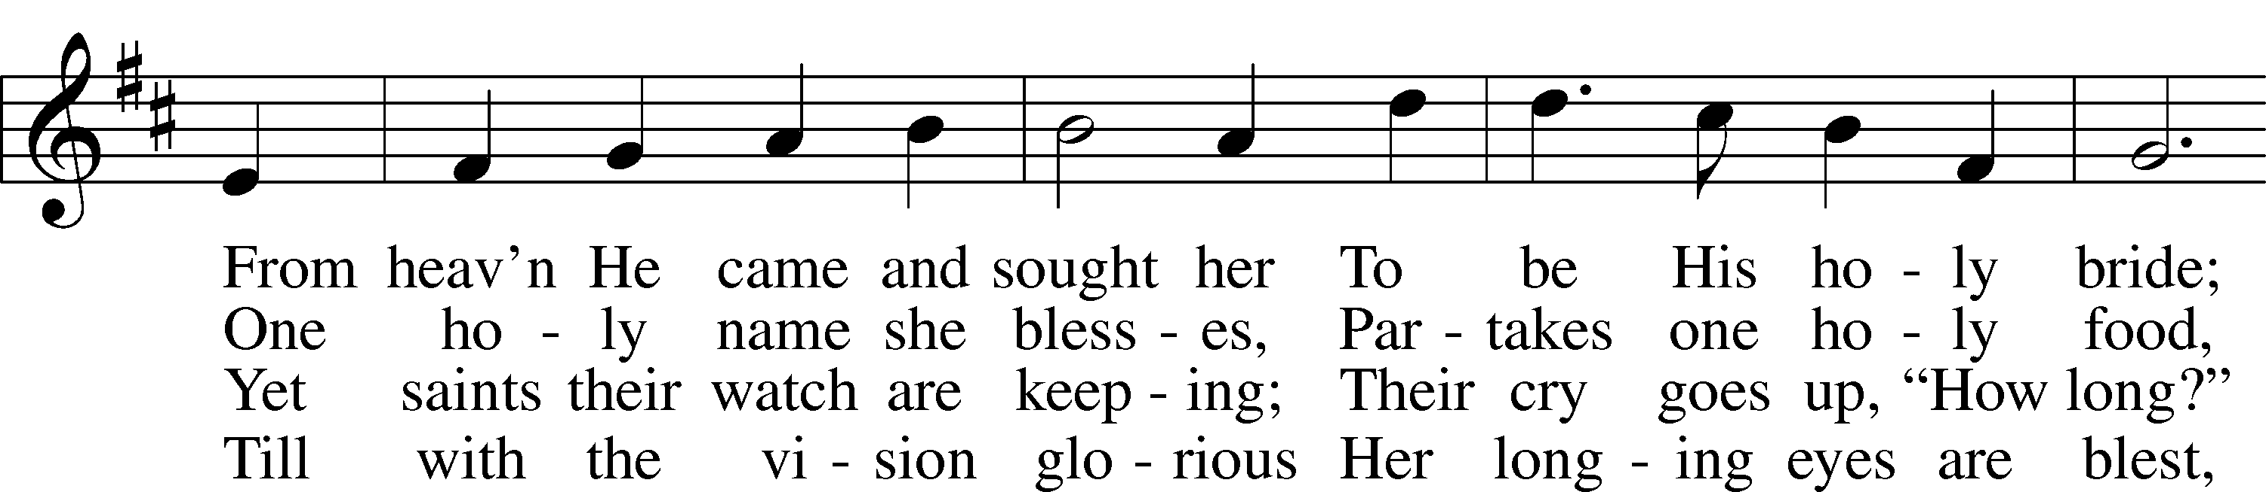
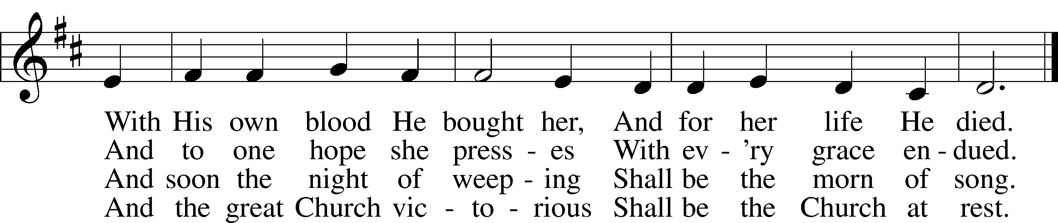

5 Yet she on earth has union
With God, the Three in One,
And mystic sweet communion
With those whose rest is won.
O blessèd heav’nly chorus!
Lord, save us by Your grace
That we, like saints before us,
May see You face to face.

Read Acts 1:12-26
1. From where were the disciples returning and what is “a Sabbath’s day journey”?

2. Following the Ascension of Jesus, where were the disciples staying and who was with them? See Acts 12:12.

3. How does Luke describe their activity in verse 14 and what does this tell you about their reaction to the Resurrection and Ascension of Jesus?

4. What do Peter’s actions in verse 15 tell us about the early church?

5. As Peter begins his speech about replacing Judas, what drives his bold suggestion?

6. Read Psalm 69:25 and Psalm 109:8 and look at the context for these verses. Why does Peter quote these Scriptural references?
7. Read Matthew 27:5. How can the accounts of Judas's death be harmonized?
8. What qualifications does Peter list for the replacement apostle?
9. What do you think of their "call" process and how does this compare to the way in which the church chooses pastors today?

Read John 17:11b-19
10. Harold Buls explains the context of this reading with the following observations:

In verses 1-5 (of John 17) Jesus prays for Himself, in verses 6-8 He speaks of what He has done for men, in verses 9-19 He prays specifically for the disciples, in verses 20-23 He prays for the unity of future believers, and in verses 24-26 He prays for the eventual glorification of all believers. The various sections overlap each other. Although verses 9-19 are spoken specifically for the disciples, they apply in their entirety to us today.

Based on this commentary, to whom is Jesus speaking in today’s text?

11. Jesus says, “protect them by the power of your name – the name you gave me…” How does John 1:1 help us understand this reference?

12. It has been said, “the unity of Christians is by grace but that the unity of Jesus and the Father is by nature.” What does this mean and how is this unity by grace accomplished?

13. How do we understand the one Jesus describes as being “lost?”

14. How could Jesus speak in verse 13 of such great joy on such a sad occasion? See verse 14.

15. Read I John 5:18. How does John bring light to Jesus’ words in verse 15?

16. According to what Jesus says in verse 19, on what does our “sanctification” hinge?

Devotional Thought from “The Lutheran Study Bible”
Knowing that He is going to the cross, Jesus prays for His disciples and asks that they be united in faith in Him. Whenever Christians ignore God’s Word, they foster divisions within the Church and diminish their witness. But God’s Word is the truth that will unite His Church, glorify Him, and enable His people to fulfill their calling in a troubled world (TLSB, 1817).

Closing Prayer
Heavenly Father, reveal in my life the love that You have shown me in Your Son. Amen.

JESUS, THE HIGH PRIEST, PRAYS FOR HIS DISCIPLES
According to the paragraphing in Nestle 26th edition, in verses 1-5 Jesus prays for Himself, in verses 6-8 He speaks of what He has done for men, in verses 9-19 He prays specifically for the disciples, in verses 20-23 He prays for the unity of future believers, and in verses 24-26 He prays for the eventual glorification of all believers. The various sections overlap each other. Although verses 9-19 are spoken specifically for the disciples, they apply in their entirety to us today.
The disciples must have heard this prayer, called the Sacerdotal, or High-priestly Prayer.

John 17:11^{b} "Holy Father, protect them by the power of your name--the name you gave me--so that they may be one as we are one."
"Holy Father" this expression is unique in the Scriptures. "Holy" is applied very frequently to the third person of the Trinity, less often to the Son, and only here to the Father. Not only is He holy in Himself but, like the Son and the Spirit, causes holiness in the life of the believer, as is immediately explained.
Jesus is asking the Father to do that which Jesus had been doing all along. The divinity of Jesus is implied. "Them" is the disciples. "Your name" is equivalent to "Your revelation," the Word of God. "To me," Jesus, denotes the human nature of Christ. This usage reminds us of the same at Luke 10:22, where the human nature of Christ is clearly meant. "So that" introduces a purpose clause. "May be" means "to continue to be." "One" denotes a unity, an analogy, not indentity. The unity of Christians among themselves is analogical, not identical, to the unity between Jesus and the Father.
Bengel aptly remarks that the unity of Christians is by grace but that the unity of Jesus and the Father is by nature, that is, their consubstantial nature. The unity among Christians is caused by the Father, working through the Word of God, and for which unity Christ prayed. Unity among Christians is not caused by Christians themselves. They discover it among themselves when they compare with each other what they believe and practice.

John 17:12 "While I was with them, I protected them and kept them safe by that name you gave me. None has been lost except the one doomed to destruction so that Scripture would be fulfilled."
During the three and one-half years of His public ministry Jesus was constantly doing what He now asks the Father to do. Note emphatic "I," the God-man. "Was with them" denotes constant and continued action. Note the repetition of words from 11^{b}.
But Jesus adds something: "I protected them" A participle, not translated here, means "furthermore." Notice "protect" and "preserved." He protected them from loss as becomes clear in the following words.
"None of them was lost" is to be taken literally. The keeping and preserving which Jesus did through the Word of God was truly effective. "Except" can mean either "except" or "but." Jesus is not saying that His keeping and preserving was ineffective in one case. "The son of perdition" is, of course, Judas. Judas was not lost because Jesus' Word could not or did not preserve him.
Bengel: He destroyed himself, Acts 1:25.
Fahling: He was chosen in good faith, but he turned traitor, and thus Scripture was fulfilled.
The purpose clause at the end of this verse cannot mean that Scripture foreordained that Judas would be lost but that no one caught God (in the person of Jesus) off guard. John 6:70.71; 13:26 make it clear that Jesus warned Judas again and again. What he did, he did deliberately, a warning to us all.

John 17:13 "I am coming to you now, but I say these things while I am still in the world, so that they may have the full measure of my joy within them."
"Now I am coming to you," Jesus, the High Priest, Who is approaching His vicarious sacrifice and praying for His disciples. The disciples heard what He said, though He was speaking to the Father. "While I am still in the world," that is, "among My disciples," as becomes clear in the purpose clause: "so that they might be having My very own joy lastingly fulfilled in themselves."
Note four things:
- It is a constant "having;"
- It is Jesus' very own joy;
- It is not partial but total;
- It is their very own.
How could Jesus speak of such great joy on such a sad occasion? Because He was certain that the Father would keep them by means of the Word and because of the joy that lay before Him, despite the cross, of sitting at the Father's right hand, Hebrews 12:2. Jesus rested in His Father's love. We rest in Jesus' love. The makes His joy complete in us, John 15:10.11.
Luther: Now if someone wants to know whether he is elected or in what relation he stands to God, let him but look upon the mouth of Jesus, that is, upon these and similar verses.

John 17:14 "I have given them your word and the world has hated them, for they are not of the world any more than I am of the world."
The word "gift" in its various forms and always denoting a gift, occurs seventeen times in this chapter, unparalleled in the New Testament. And "world" in its various meanings occurs eighteen times, also unparalleled. Note emphatic "I have given" denotes a lasting gift, perfect tense.
Lenski: This time he uses a word which points especially to the substance; but he retains the verb 'to give' for the Word is always a pure gift which emanates from grace in the Giver.
We so easily grow tired of the Word of God or take it for granted. It is always a gift. This gift comes to us as a gift from the Father through Jesus Himself.
"The world" here means the unbelieving among men. Their reason for hating disciples is now given. "They are not of the world" means "of the nature of the world." He means the sinful world. Jesus, in His own right, is not of the nature of the world. His disciples, by their union of faith in Jesus, likewise are not of the nature of the sinful world. The world hates Christians because they have the gift of God in Christ, His Word. This is a burden which Christians must bear.
Kretzmann: There is no need of following the lead of enthusiasts that prate of new revelations, the inner light, and keys to Scriptures. The Word of the Gospel as we have it in Scriptures is all-sufficient for all needs.

John 17:15 "My prayer is not that you take them out of the world but that you protect them from the evil one."
"You" is here used of an equal to an equal, unlike a formal "Thou" which is used of an inferior toward a superior. Therefore, the divinity of Jesus is implicit.
Jesus does not will or pray for our separation from the world, though it be sinful, but our preservation from the evil one, the devil. How this is done is clear from verses 11 and 17. The devil is the most formidable enemy known to us. He is a liar and murderer and works through his agents among men, John 8:44. He constantly goes about like a hungry and raging lion, 1 Peter 5:8. At 2 Corinthians 11:13.14 Paul tells us that false prophets appear as Apostles of Christ but no wonder, for Satan himself appears as an angel of light. Satan constantly tempts us as he did Christ, Matthew 4:1-10. But Jesus has conquered Satan, Luke 10:10, and therefore has given us the authority to tread on Satan's great power, Luke 10:19. This does not mean that Jesus' disciples are sinless. But from God's point of view the believer does not sin because Jesus Himself keeps that person and so the devil cannot touch him, 1 John 5:18. If it weren't for the Atonement, Jesus' prayers to the Father, and the Word of God, we wouldn't stand a chance, no matter how pious we might appear.

John 17:16 "They are not of the world, even as I am not of it."
Compare this verse with 14^{b}. Because of the prayer of Jesus, the Father keeps them from Satan. This is what separates them from the sinful world and its nature. Jesus does not pray that the Father keep Jesus from Satan. He needn't ask that for He is true God and He Himself conquered Satan in our behalf. Because of this victory the Father keeps believers from Satan through the Word so that, like Jesus, they are not of the world.
Ylvisaker: Jesus knows the world better than do the disciples.
Verse 16 leads right into verse 17. Note that in both verses 15 and 17 the object is the disciples, not Jesus. He is not praying for what the Father should do for Him but for the disciples.

John 17:17 "Sanctify them by the truth; your word is truth."
Bengel: Claim them wholly to Thyself.
Kretzmann: The Christians are sanctified, separated from the world, as soon as faith had been worked in their hearts.
Lenski: 'Sanctify'means to set apart for God and to devote only to Him.
Only God can accomplish this. Man, no matter how pious or respected he may be, cannot do it by his own works, worthiness, prayers or endeavors. How does God accomplish this? "By the truth," a prepositional phrase denoting manner or means.
Thayer: Truth: The truth, as taught in the Christian religion, respecting God and the execution of his purposes through Christ, opposed alike to the superstitions of the Gentiles and the inventions of the Jews, and to the corrupt opinions and precepts of false teachers even among Christians.
Well said. And then Jesus adds: "Your Word is Truth." The substance of God's Word, both Law and Gospel, is Truth. The Christian, like Christ, is not of the world which is constantly floundering and sinking in a sea of uncertainty. Only the Father, at the prayers of Jesus, can AND DOES sanctify, set aside, assure, make certain and confident. And He does this by means of the THE TRUTH, THE WORD OF GOD.

John 17:18 "As you sent me into the world, I have sent them into the world."
Another "just as," the fourth and last in our text. Go back and look at the other three in verses 11, 14, 16. The communion of saints is a unity like that of Father and Son. The unbelieving world hates believers because Jesus has given them the Father's Word, but worry not for this is a proof of the fact that they are not of the world, just as Jesus is not of this world. You are not alone. Believers are not of the world because the Father Himself sets them aside, and this He does through the Word.
Back to verse 18: We cherish Christmas because on that occasion we remember that the Father sent His Son among men, into the world. The difference between what the commission of Christ accomplished, and what the commission of the disciples accomplishes is brought out in verse 19, but we mention here that, in a sense, every day of the life of a Christian is like Christmas because Jesus is sending the Christian among men, into the world. This commission covers the entire life of the Christian: his public and private life, his relationship to members of his family, the use of time, confessing Jesus in word and deed before men, etc.

John 17:19 "For them I sanctify myself, that they too may be truly sanctified."
The Father sent the Son as the great Highpriest. Verse 19 grows out of verse 18. Disciples cannot be sent until they know what is said in verse 19. "In their stead," is vicarious. In their stead Jesus sanctified Himself, set Himself aside for the purpose of suffering, dying, rising again, ascending to the Father in the stead of and for the sake of the disciples. "May be" is the perfect passive participle and is durative, denoting consummation, not just in the life to come, but now already. And "sanctify" repeats what He said in verse 17, "by means of Truth," the Word of God. Forms of "sanctify" occur three times, once in 17 with the Father as Sanctifier through the Word, secondly in 19 with the Son Who sanctifies Himself (the vicarious atonement), and finally in the passive voice of the disciples who have been sanctified through the Truth.
In verses 6-19 Jesus prays only for His own, His disciples, you and me too. In verse 6 He says: "I do not make request for the world." This passage does not deny the universal atonement. As someone has said: "Jesus is not praying against the world." But in this passage He prays only for His disciples to assure them of the things that are the most necessary:
- The actual unity of all believers in the Father and the Son;
- The gift of the Word from the Father and the Son which assures us that we will not be lost and which separates us from the unbelieving world and Satan;
- That the joy of Christ is our very own;
- That we should not become be disconcerted over the hatred of the world;
- That the Son sanctified us through the Word, the Truth;
- That the life of the Christian has a true purpose, as certain as that of the sending of the Son into the world.
The whole passage is purest Gospel.

