Pastor’s Bible Class

The Fourth Sunday after the Epiphany

# 578 “Thy Strong Word”

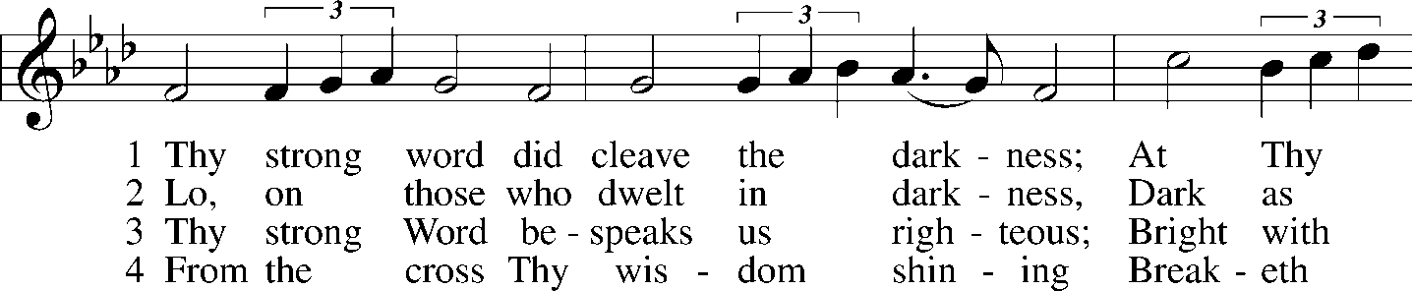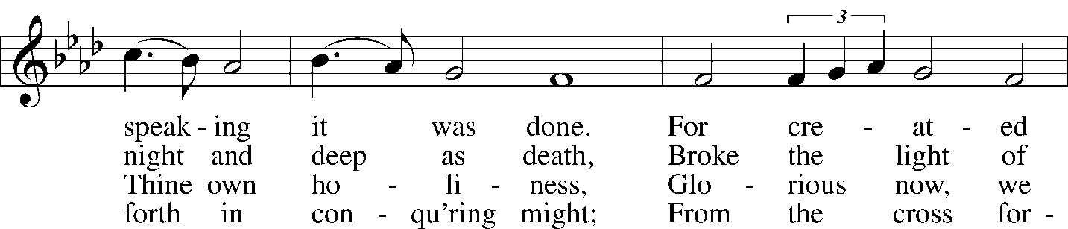
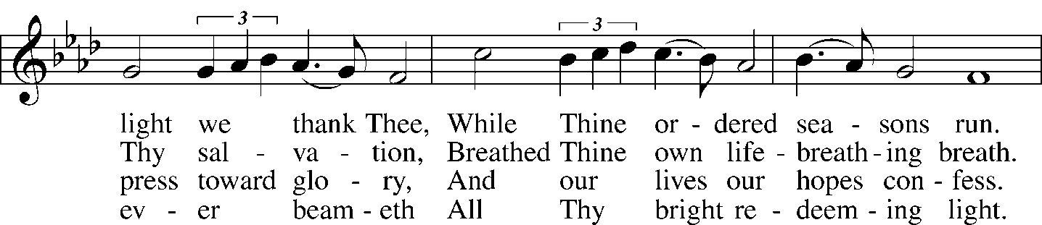
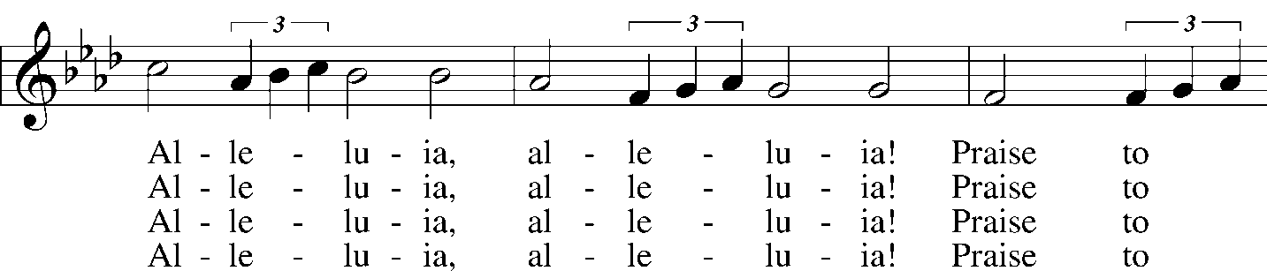
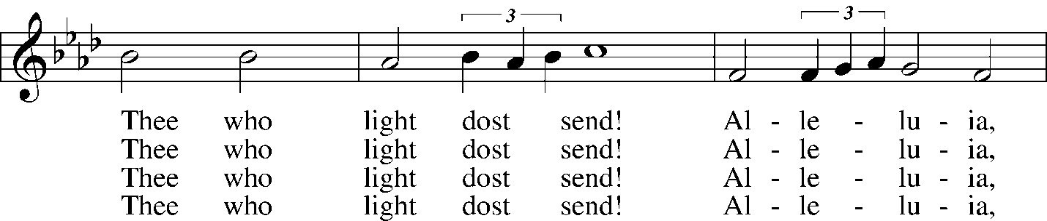
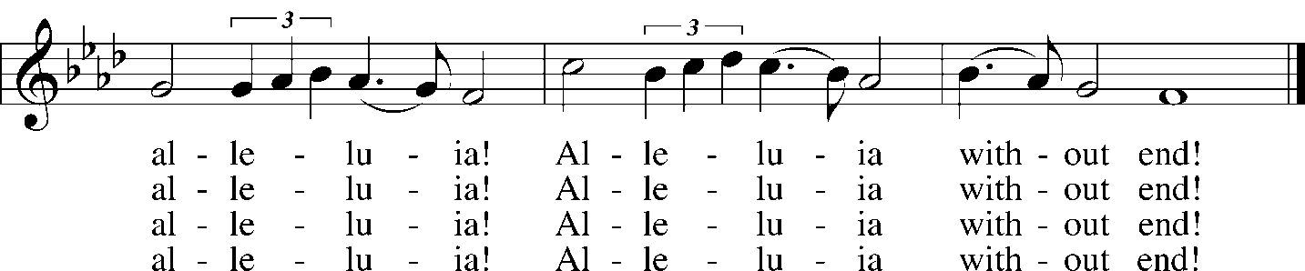

5 Give us lips to sing Thy glory,  Tongues Thy mercy to proclaim,  Throats that shout the hope that fills us,  Mouths to speak Thy holy name.  Alleluia, alleluia!  May the light which Thou dost send  Fill our songs with alleluias,  Alleluias without end! | 6 God the Father, light-creator,  To Thee laud and honor be.  To Thee, Light of Light begotten,  Praise be sung eternally.  Holy Spirit, light-revealer,  Glory, glory be to Thee.  Mortals, angels, now and ever  Praise the holy Trinity!
Read Jeremiah 1:4-10, 17-19:
- What was the task the God gave Jeremiah?
- What excuses did Jeremiah make?
- When do we sometimes get overwhelmed with our spiritual tasks?
- How is 1 Corinthians 10:13 help?
- How did God equip Jeremiah?
- How can God equip us?
Read 4:31-44:
- Jesus had not been rejected in Nazareth (4:14-30). How is He received in Capernaum? (vv. 32, 36-37)
- From where did He get His authority as opposed to the Scribes and Pharisees?
- How can we, too, speak with authority to situations where spiritual matters run into earthly situations?
- Only Luke has the healing of Peter’s mother-in-law. Why do you suppose that is?
- How was Peter’s mother-in-law’s response a good example for us in our daily lives?
- How does Jesus set a great example for us in verse 42?
- What do verses 42b - 44 tell about how Jesus determined His priorities while He was on this earth?
- What can we learn from verses 42b-44 for our lives?

Devotional Thought and Closing Prayer (The Lutheran Study Bible)
With authoritative words, Jesus silences and sends away unclean spirits. God’s Word bears authority for your sake, too, pointing out your uncleanness due to sin, yet also promising deliverance from sin and from attacks of the evil one. Revel in Jesus’ teaching and its great blessings for you. Jesus heals many people by a word and a touch. His works reveal the bond between sin and sickness, which corrupts the world and touches our lives. Pray that Jesus would deliver you from evil and protect you from the effects of sin. Christ can forgive and restore you by His grace. (TLSB, 1715-16).

Prayer
Restore me, precious Savior, that I may trust your Word fully and serve You faithfully. Amen.

