Pastor’s Bible Class

The Third Sunday after the Epiphany

#904 “Blessed Jesus, at Your Word”
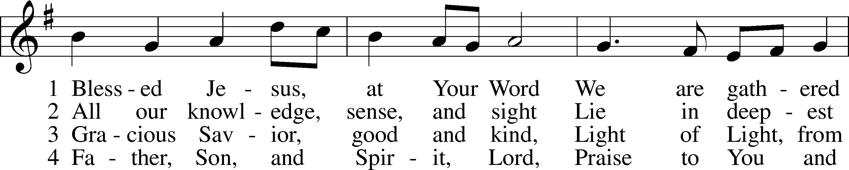
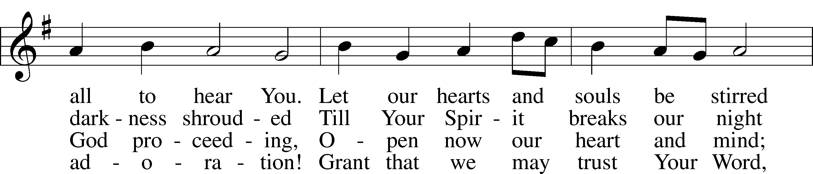
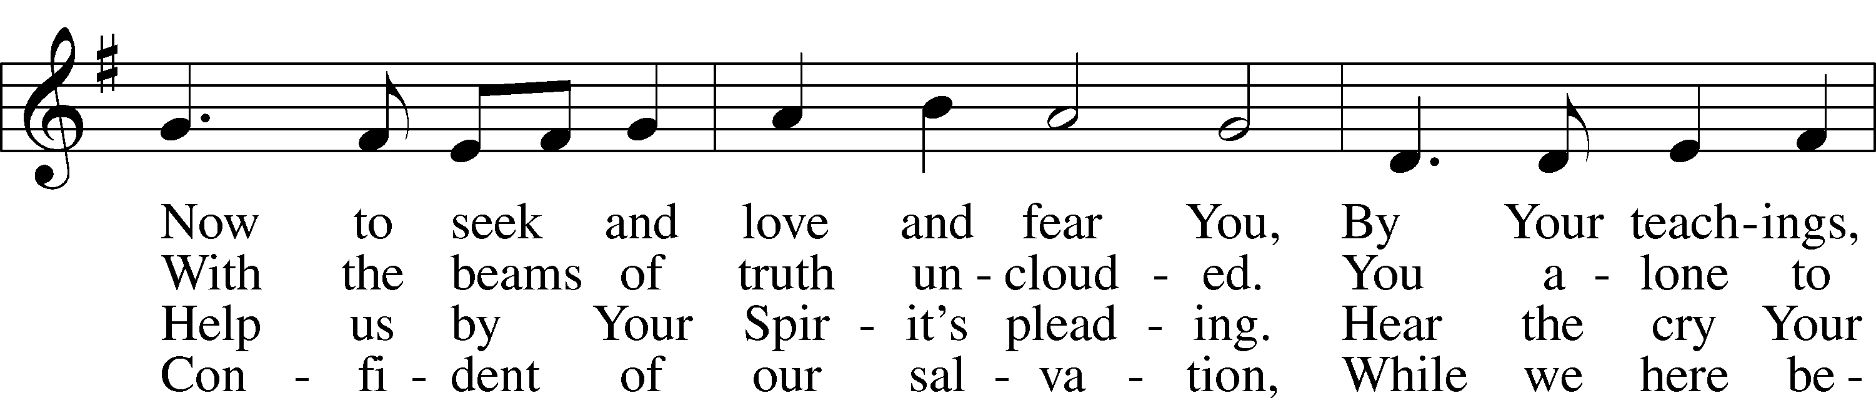
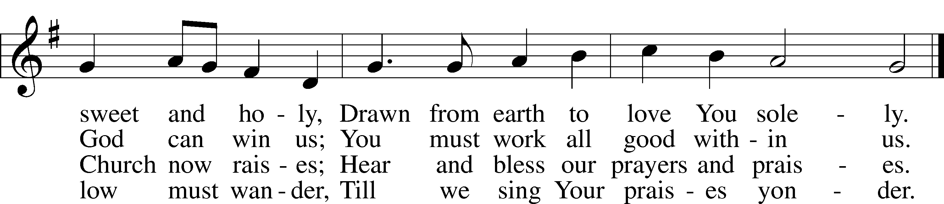

Read Nehemiah 8:1-3, 5-6, 8-10
1. When the Lord released His people from Babylon and returned them to Jerusalem, “Ezra the priest and scribe, and the Levites who taught the people,” sanctified the whole congregation by the reading and preaching of the Law (Nehemiah 8:8–9). Who gathered for this historic reading of God’s Word according to verse 1?

2. How did the people react to the reading of the Law? What did this reaction demonstrate?

3. Why is verse 8 so important and how does it relate to our status as a “confessional” church?

Read Luke 4:16-30
4. What important information does Luke provide in the verses leading up to today’s text?

5. Our reading begins in verse 16 with a statement of setting that reveals important details about Jesus? What do we learn in this verse?

6. What does the reading from the scroll of Isaiah describe?

7. How do the actions of Jesus in verses 17-21 connect with Nehemiah 8:8?

8. In simple terms, what is His interpretation of the Isaiah text?

9. What’s behind the question asked by the people in verse 22?

10. What does Jesus reveal about the hearts of the people to whom He is speaking in verse 23?

11. In verses 25-27, Jesus uses two illustrations from Scripture, one of a pagan widow and the other of a pagan general, to reveal the rejecting and proud attitude of the people of Nazareth. What about these illustrations makes the people so “furious” that they would try to “throw him down a cliff”?

12. How does this text foreshadow Jesus’ entire ministry?

Devotional Thought and Closing Prayer (The Lutheran Study Bible)
“Jesus ministry begins with victories over Satan…but also with an episode in Nazareth that foreshadows His rejection at the hands of His own people. Our lives typically include a similar mixture of success and rejections. That is why we do well to focus more on the end of the Gospel story, for there we see resurrection, God’s greatest victory over sin and the devil, and the revelation of His grace and mercy for us” (TLSB, 1715).

Prayer
Eternal God, give me grace when I face temptations from the devil and assaults from the unbelieving world. Remind me that You have already overcome these things for me and even now are preparing a place for me in Your eternal presence. Amen.

