Pastor’s Bible Class

The Third Sunday in Advent – Series C

#346 “When All the World Was Cursed”
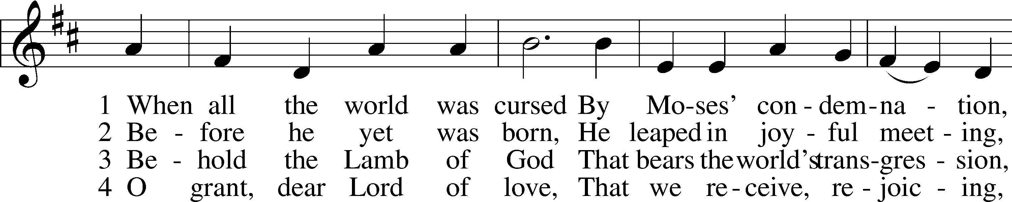
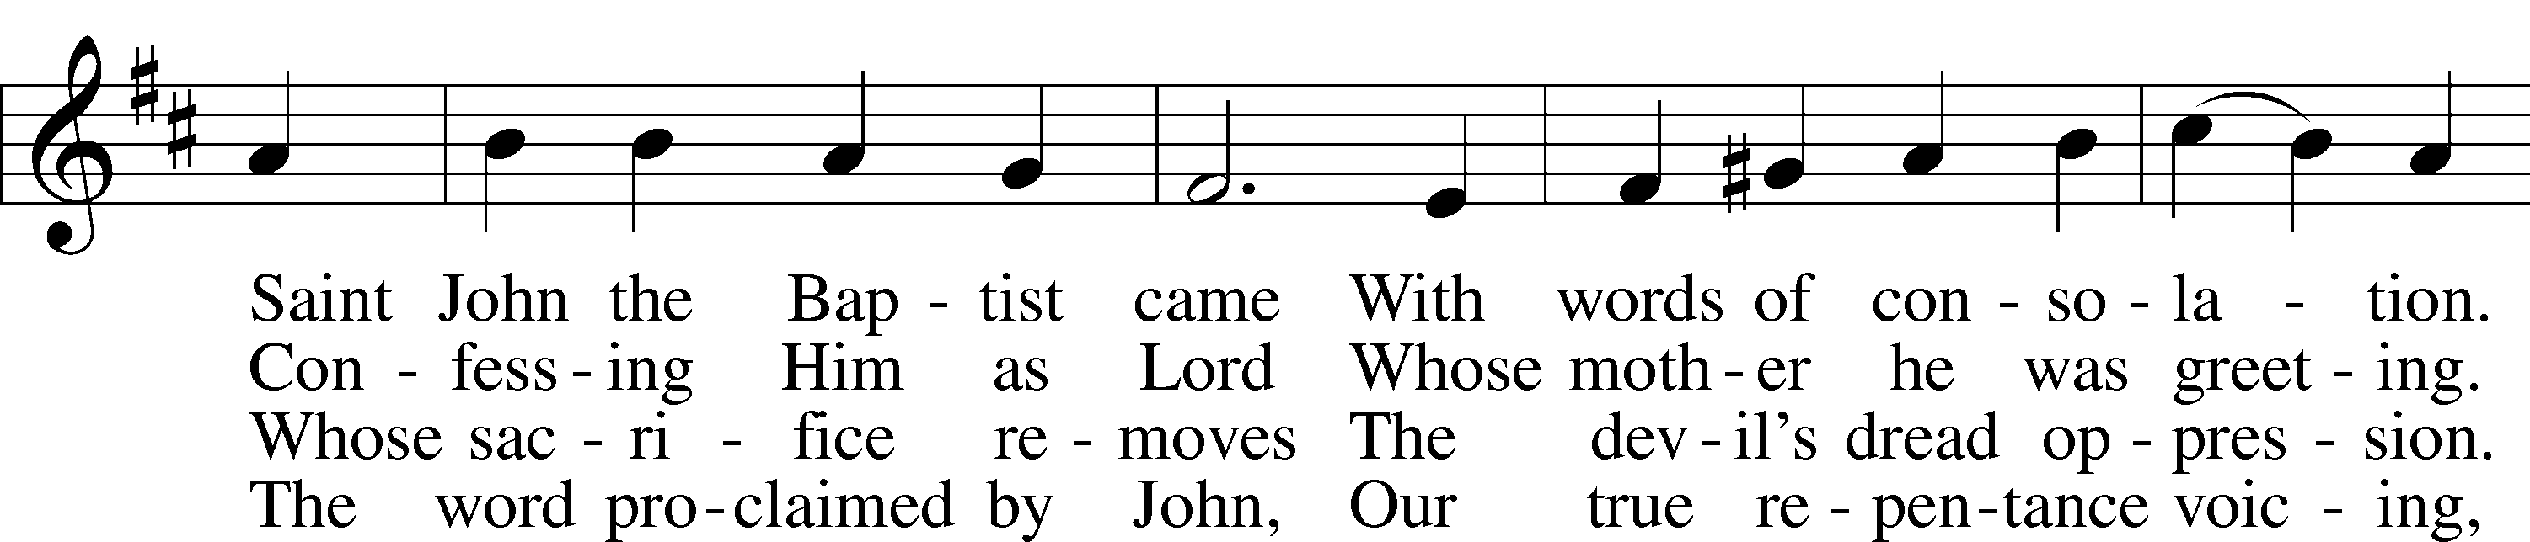
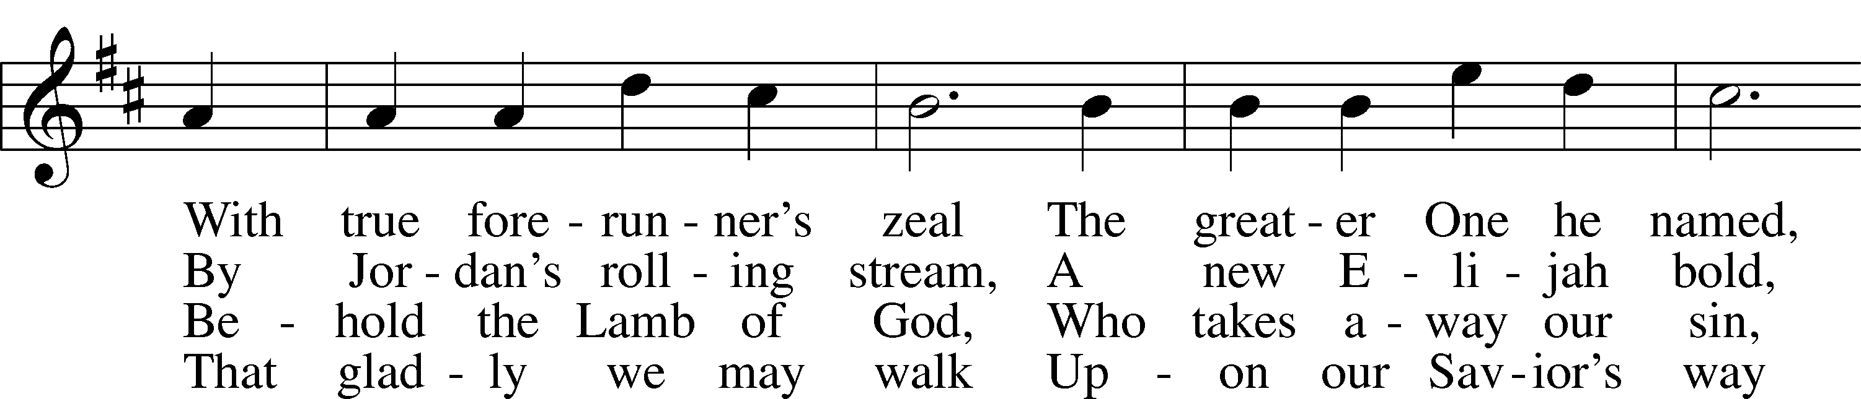
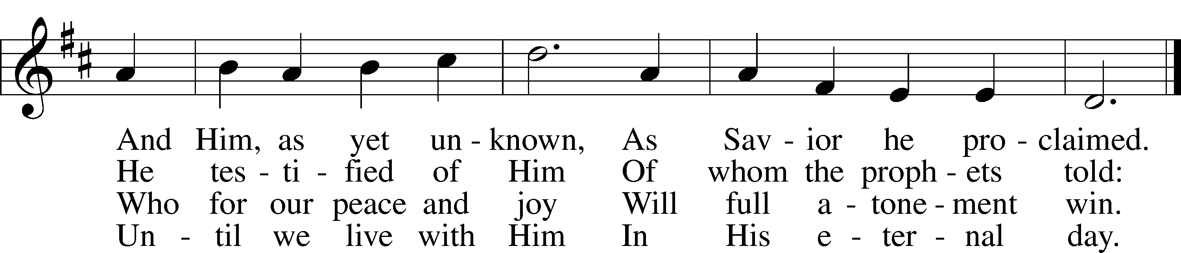

Read Zephaniah 3:14-20
1. The prophet begins with the greeting “Sing aloud, O daughter of Zion…Rejoice…O daughter of Jerusalem.” What do these titles mean? See Hebrews 12:22-23.

2. What promises does God give His people in this reading?

A. Zephaniah 3:15

B. Zephaniah 3:17

C. Zephaniah 3:18
3. What different messages are heard in this reading and why are they appropriate for Advent?

Read Luke 7:18-28
4. What did Luke mean by “all these things” when referring to the report of John’s disciples in verse 18?

5. Why does John doubt?

6. How does Jesus respond to their question (and John’s doubts) in verse 21?

7. Read Deuteronomy 18:21-22. How is this Old Testament promise reflected in the actions of Jesus in Luke 7:21?

8. Read Isaiah 26:19; 29:18; 35:5-6; 42:18; 61:1-2. How do these verses help us to understand Jesus’ words to John’s disciples?

9. What does Jesus mean when he says, “Blessed is the man who does not fall away on account of me?” See also I Corinthians 1:22.

10. John has been referred to as a hinge between the Old and New Testaments. In what ways is John an “Old Testament” character? In what ways is he a “New Testament” character?

11. How does John’s status as a hinge character help explain Jesus’ comments in verse 28?

Devotional Thought (The Lutheran Study Bible)
“In response to doubt and criticism, Jesus affirms that He is indeed the Messiah announced by John and that John, who heralded His advent, is Israel’s greatest prophet. Yet, many will accept neither John’s thunderous warnings nor Jesus’ proclamation of the Good News of the kingdom. Such skepticism continues today. Thank God conversion is God’s work though His Word. God’s Spirit continues to enlighten, sanctify, and keep us in the true faith” (TLSB, 1724).

Prayer
“Holy Spirit, light divine, Shine upon this heart of mine; Chase the shades of night away, Turn the darkness into day” (LSB, 496:1).

