Pastor’s Bible Class

The Twentieth Sunday after Pentecost

#858 “O Father, All Creating”
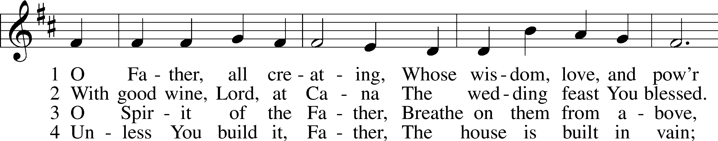
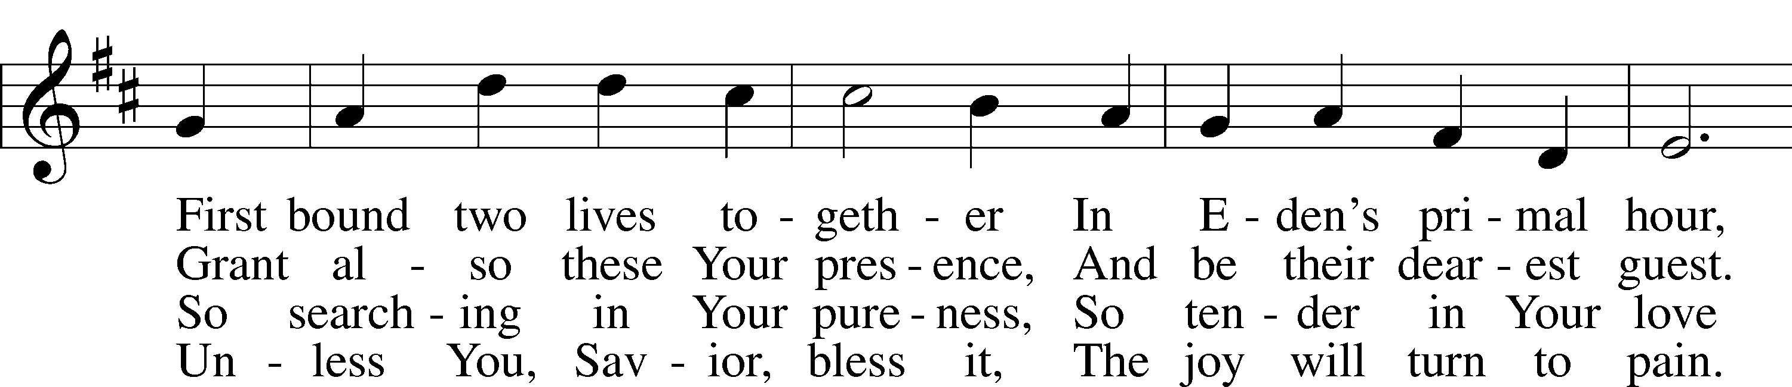
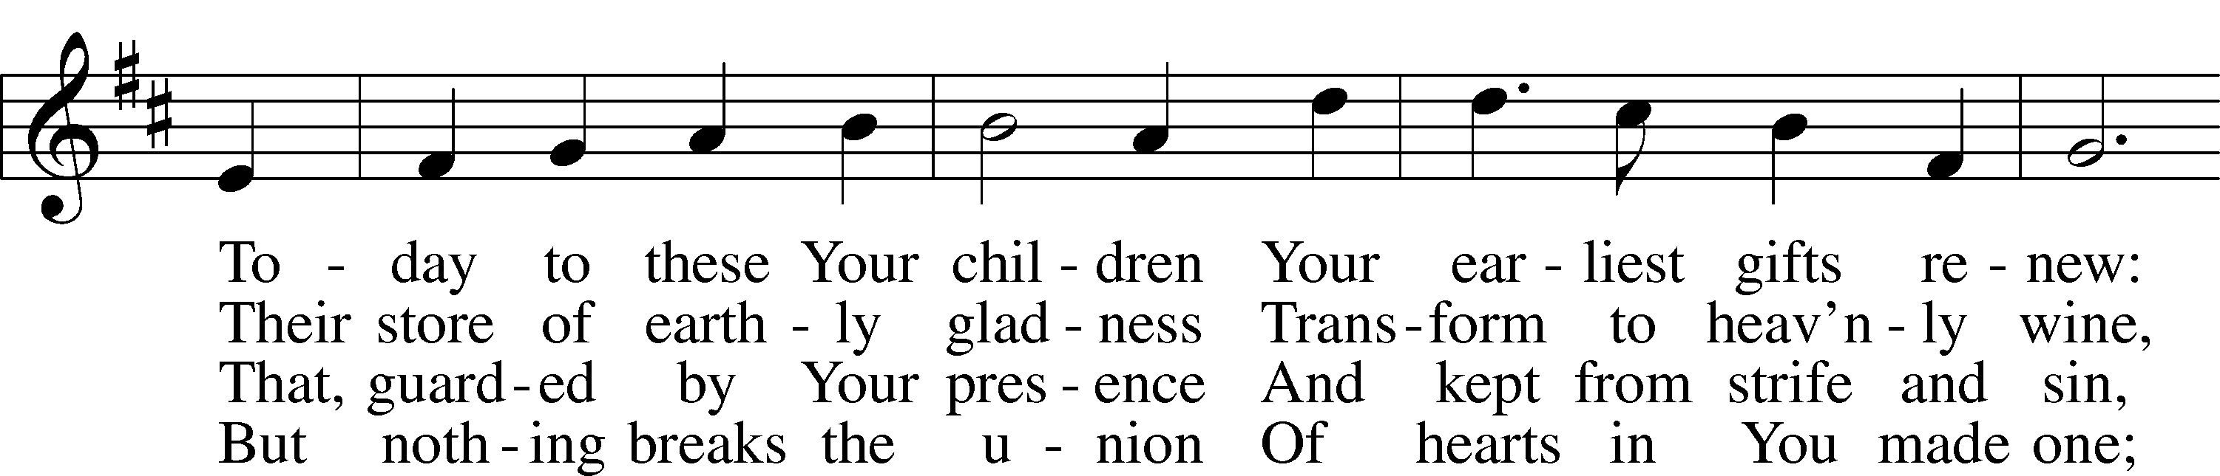
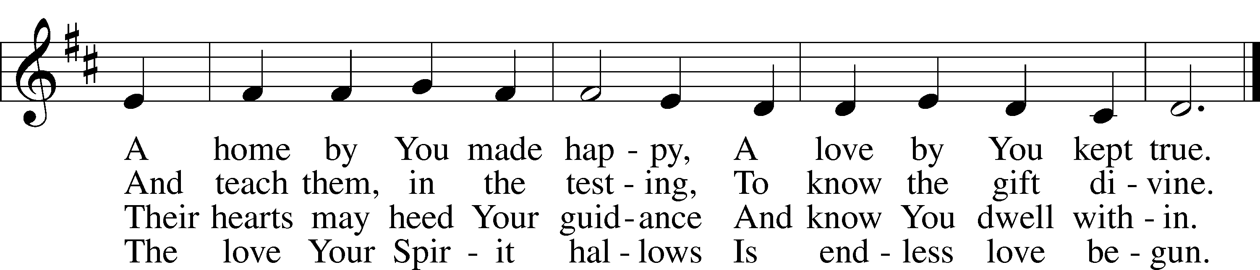

Read Genesis 2:18-25

1. What declaration does God make in verse 18 and what does this tell us?

2. What important details do we learn about the creation of “the beasts of the field and the birds of the air” in verse 19?

3. God gives Adam the task of naming the animals. What is the result of this exercise?

4. The New King James Version states, “But for Adam there was not found a helper comparable to him.” What does “comparable” mean in this case? See Genesis 1:26.

5. Verse 23 constitutes Adam’s first recorded words. What do these words tell us about Adam’s reaction and relationship to Eve? See also verse 25.

6. How are we to understand the words of verse 24?

Read Mark 10:2-16

7. In what spirit do the Pharisees approach Jesus?

8. To what does Jesus refer the Pharisees and why? Read Deuteronomy 24:1-4.

9. R.T. France writes,
“While Jewish authorities debated the grounds for divorce, no one questioned that divorce was permissible. After all, had not Moses given explicit directions to regulate it (Deuteronomy 24:1-4)? Some taught that the ‘something objectionable’ mentioned in Deuteronomy 24:1 meant adultery and nothing more, while others (primarily Jewish men) taught that it could cover even quite trivial matters like bad cooking or even not being pretty enough” (France, R.T. Mark: Doubleday Commentary. 1998).

How does Jesus explain the words of Moses in verse five? Note the pronoun used by Jesus.

10. How are we to understand this today? See also Malachi 2:14-16.

11. Understanding the cultural background described in question nine, how does Jesus clarify His teaching to the disciples?

12. Divorce is a commonplace occurrence in today’s world. What is the proper Biblical position on the reality of divorce, and how should the church minister to those men and women who have gone through a divorce?

Devotional Thought (The Lutheran Study Bible)
“Jesus teaches that God wants a man and a woman in marriage to be exclusively committed to each other for life. Attempts to get around God’s good intentions bring condemnation, not greater liberty. Thoughtfully and prayerfully embrace God’s ways. What He establishes is for our good and stems from love and grace” (TLSB, 1678).

Prayer
Forgive us, Lord, for our eagerness to find the easy way out, and our fear of facing up to your full demand. Restore to us and to our society the vision of marriage as you meant it to be. Amen.

DIVORCE;
JESUS INVITES BABIES
At first glance it may appear that verses 1-12 have nothing in common with verses 13-16. But they have this in common that the disciples still have much to learn. Verses 1-12 are paralleled at Matthew 19:1-9. Matthew is briefer but is writing for a Jewish audience. Mark is clearly writing for a Gentile audience. Verses 13-16 are paralleled at Matthew 19:13-15 and Luke 18:15-17. A very important principle, enunciated by all three.

Mark 10:1 Jesus then left that place and went into the region of Judea and across the Jordan. Again crowds of people came to him, and as was his custom, he taught them.
At this point we are in the later Perean Ministry, the final three and a half months of Jesus' ministry.
Stoeckhardt: This was the last province of the land of the Jews which received His gracious visitation.
Jesus was constantly teaching the crowds and His disciples.

Mark 10:2 Some Pharisees came and tested him by asking, "Is it lawful for a man to divorce his wife?"
Pharisees had plagued Jesus in Judea, Galilee, and now even in Perea. Their sole motive is like that of Satan in Matthew 4:1. It shows the spirit in which they asked the question. They wanted to destroy Him.

Mark 10:3 "What did Moses command you?" he replied.
Jesus always appeals to the Old Testament. So did the Pharisees but their exegesis always missed the mark. By the way, Jesus clearly stresses the Mosaic authorship of the Pentateuch and is saying: "Moses' word is God's Word."

Mark 10:4 They said, "Moses permitted a man to write a certificate of divorce and send her away."
Ylvisaker: This was one of the burning questions of the day between the two schools in Israel, those of Hillel and of Shammai. The latter was the more strict and conservative, while the former was liberal and tolerant to a degree. . . In spite of mutual disagreements, both schools were agreed that divorce was justified for causes other than that of adultery in the strict sense of the word.
Deuteronomy 24:1 is from a section of Jewish POLITICAL Law, not MORAL Law.
Stoeckhardt: Moses was also a civil law-giver. In Israel there were many immoral people who would not submit to God's Law.
Hendriksen: The 'certificate of divorce' was a merciful concession made for the sake of the wife, for without this regulation a harsh man might be inclined to dismiss his wife even without giving her any written evidence that she was now no longer married.

Mark 10:5 "It was because your hearts were hard that Moses wrote you this law," Jesus replied.
"Hard hearts" amounts to unbelief. Look at Mark 16:14. NEB: "Because you were so unteachable." Beck: "On account of your closed minds." Note "your" not "their." Jesus includes the Pharisees and the schools of Hillel and Shammai. This arrangement was a gracious concession, not an approval of obvious sin.

Mark 10:6 "But at the beginning of creation God 'made them male and female.'"
This little "but" shows that their interpretation was contrary to Moses' word, which is God's Word. The creation principle of marriage is now stated by referring to Genesis 1:27; 2:24; 5:2.

Mark 10:7 'For this reason a man will leave his father and mother and be united to his wife,
"For this reason," because of this creation principle. "Will leave" and "be united" are not mere predictions but enunciate the creation principle for all times and peoples.

Mark 10:8 and the two will become one flesh.' So they are no longer two, but one.
"Two will become one" rules out divorce and polygamy. "One flesh" is applied only to marriage, to no other human relationship.

Mark 10:9 "Therefore what God has joined together, let man not separate."
"Therefore" this is how mankind should view it. "Man" here means "any human being." In verse 7 it means "a husband." When people marry, God thereby yokes them together. Every valid marriage must be considered such a divine yoking. The creation principle is involved. If disregarded, it proceeds from unbelief. The marriage is God's yoking, and presents a lasting principle.

Mark 10:10 When they were in the house again, the disciples asked Jesus about this.
They ask in private. The Pharisees are no longer with them. The disciples, much influenced by the lax thinking of the school of Hillel, needed further instruction.

Mark 10:11 He answered, "Anyone who divorces his wife and marries another woman commits adultery against her."
"He answered" is "He went on to say." He states another principle. It is always so, no exceptions. Jesus does not mean that adultery is not committed until he marries another but rather that this marrying another aggravates the adultery. Most translations: "Commits adultery against her (his wife)." The real point is that not only is he sinning but is also offensive to another. The exception "except it be because of fornication" mentioned at Matthew 5:32 and 19:9 is not mentioned here but is implicit in the text.

Mark 10:12 "And if she divorces her husband and marries another man, she commits adultery."
This verse is found only in Mark who was writing for Gentiles. What is said about the husband dismissing his wife is equally true about the wife dismissing her husband. This again is a present general condition which holds true in all cases.

Mark 10:13 People were bringing little children to Jesus to have him touch them, but the disciples rebuked them.
Luke clearly has "babies" and therefore Beck rightly translates: "Babies." RSV, NEB and NASB are weak: "children." There is nothing magical or mechanical in His touch. To touch is an indication of love and intimacy. Those who brought the babies very likely believed in Jesus. That is the point. NEB: "Scolded them." A strong word. The disciples had a lot to learn. "Them" does not mean they were only men, this very likely includes mothers, believing mothers.

Mark 10:14 When Jesus saw this, he was indignant. He said to them, "Let the little children come to me, and do not hinder them, for the kingdom of God belongs to such as these."
Beck: "He didn't like it at all." Beck continues: "don't keep them away, even to these belongs the Kingdom of God." Not only to adults but even to these. The disciples, like many moderns, were denying this. The Kingdom of God is the gracious rule and reign of God in the hearts of people for Jesus' sake.

Mark 10:15 "I tell you the truth, anyone who will not receive the kingdom of God like a little child will never enter it."
An emphatic truth is enunciated. What follows in this verse allows of no exceptions. "Like a little child" must mean "as a child receives it" thereby plainly indicating that babies can believe. Unless a person has a baby-like faith he cannot "enter it," be reconciled to god through faith in Christ.

Mark 10:16 And he took the children in his arms, put his hands on them and blessed them.
Jesus did three things; embraced them, placed His hands upon them, began blessing them. The latter surely with His Word.
Ylvisaker: The Church has justly recognized in this passage one of the important arguments for the practice of infant baptism . . . Jesus declares that little children are fit for the Kingdom of God through faith . . . And the Church has discovered even more in this passage, the actual origin, in truth, and the institution of the sacrament of Baptism. And so it is. The first ordinance was not given when Jesus commanded His apostles to go and make disciples of all nations through baptism and instruction (Matthew 28:19ff).
That is correct. Compare John 4:1-3.
Though the disciples believed that Jesus was the Messiah, verses 1-16 tell us that they still had much to learn. And so it is with us.
Verses 6-12 do not say that divorce, for reasons other than fornication, is an unforgivable sin. When a sinner repents, when a divorcee repents, he (or she) should be absolved. But Jesus is saying that to break a marriage indicates unbelief, a disregard for the Word and will of God.
The criterion for becoming a child of God is not adults but babies to whom the Kingdom of God belongs. Rationalism turns this principle around. And even many who agree to infant baptism declare that it is merely a sign and that they must later "surrender" to Christ. Hendriksen, a Reformed theologian, says these very things at this point. He thereby denies the efficacy of baptism and shows his synergistic theology.

