Pastor’s Bible Class

The Twenty-first Sunday after Pentecost

#700 “Love Divine, All Loves Excelling”
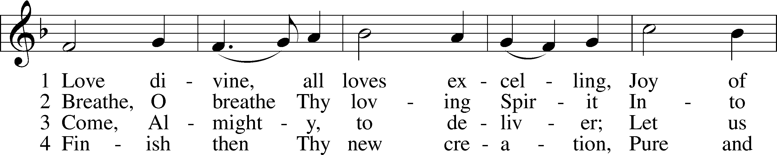
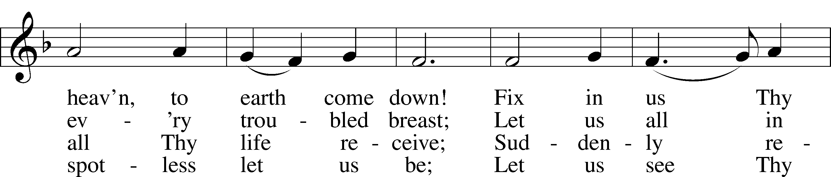
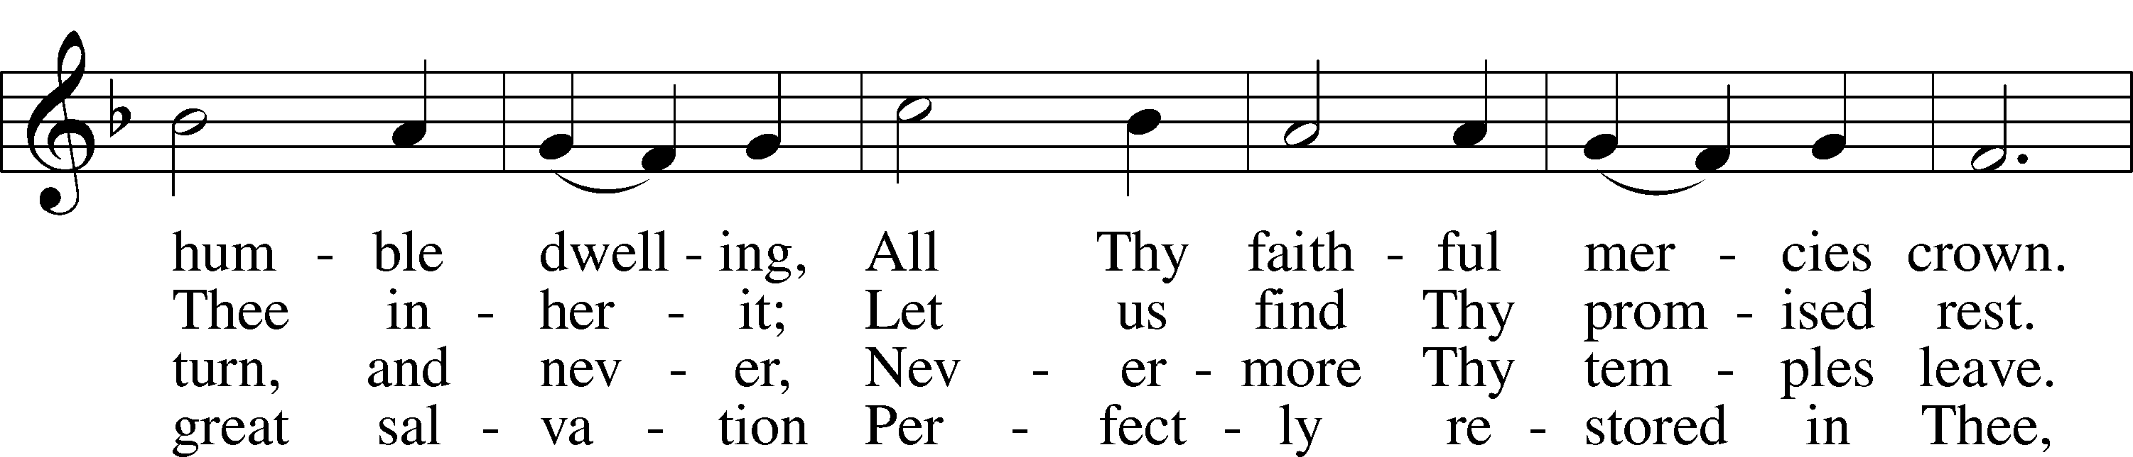
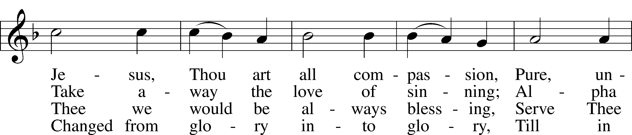
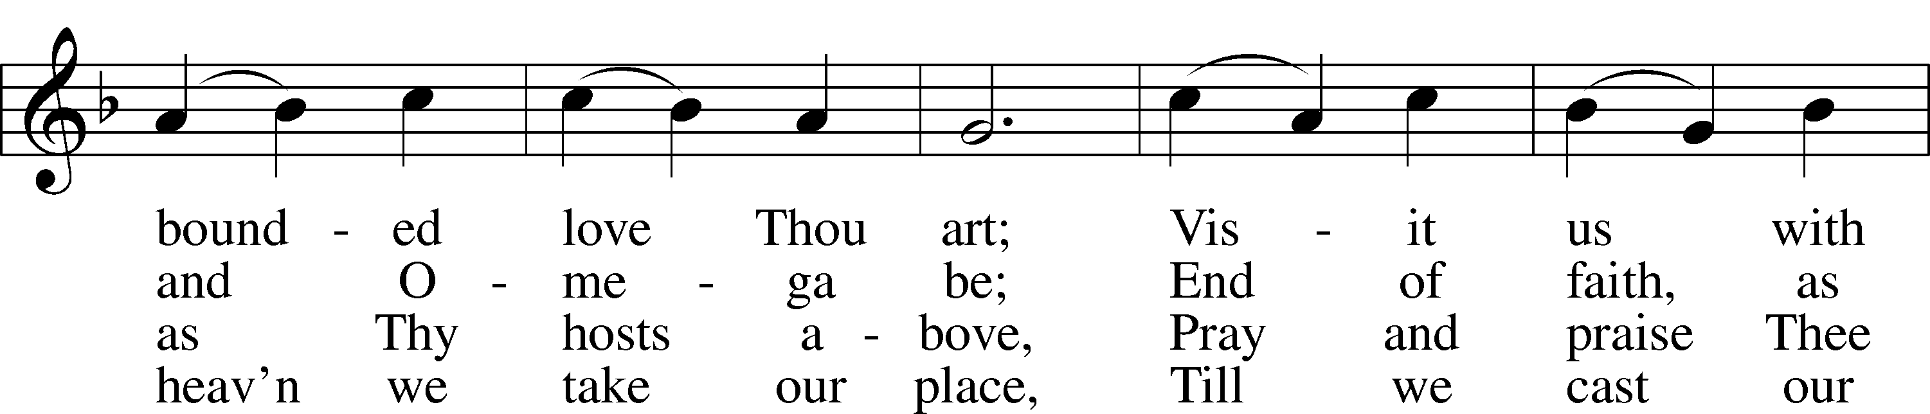
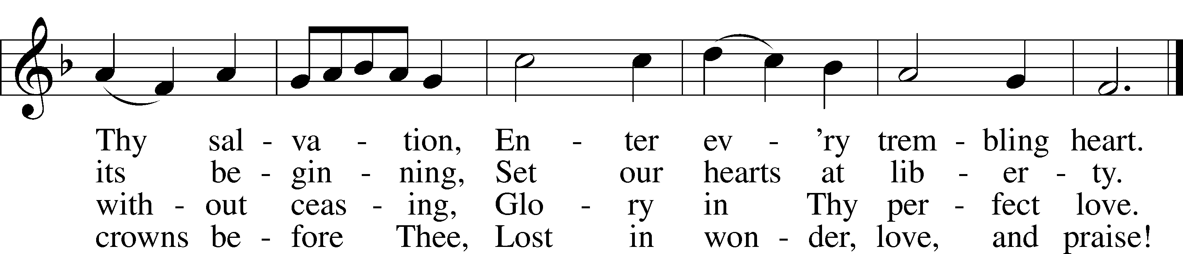

Read Amos 5:6-7; 10-15
1. Amos prophesied during a time of great prosperity in both the Northern and Southern kingdoms. It was also a time of idolatry, indulgence, immorality, and the corruption of judicial procedure and oppression of the poor (Concordia Self-Study Bible, p. 1350). What sins are enumerated in verses 10-12?

2. Our text begins with the words, “Seek the Lord and live…” and ends with the admonishment to “seek good…that you may live.” What do these words mean for us?

Read Mark 10:17-22
3. What does the man’s approach and greeting tell you about his opinion of Jesus?

4. How does Jesus’ response to the man’s question redefine the term “good?”

5. In verse 19, Jesus references the Ten Commandments. Which commandments does he leave out? Hint: Consider the commandment to “not defraud” as representative of the Ninth and Tenth Commandments.

6. The man responds to Jesus by stating, “all these I have kept since I was a boy.” What does this tell us about the man’s understanding of sin?

7. How does Jesus respond to the man’s shortsighted understanding?

8. Jesus’ directive to the man seems anything but loving. Why did Jesus respond in this way?

Devotional Thought (The Lutheran Study Bible)
“Jesus teaches His disciples that not even people with the greatest worldly means can enter the Kingdom of God on their own merit. We cannot justify ourselves; we receive salvation (and inherit eternal life) solely by grace through faith in Jesus, just like a little child” (TLSB, 1680).

Prayer
“My heart’s delight,
My crown most bright,
O Christ, my joy forever.
Not wealth nor pride
Nor fortune’s tide
Our bonds of love shall sever” (LSB, 557:4). Amen.

Reminder
Due to all of the activities associated with Grandparents’ Day we will NOT meet next Wednesday, October 17th.

